AI Imposter – Hackathon
Members:
Daniel Chernov
Tuval Zitelbach
Yosef Perelman



Description
AI Imposter is a real-time multiplayer party game where players answer funny questions and try to identify which answer was written by AI.
Each round starts with a funny question. Every human player submits an answer, and the system also generates one AI answer using AI API. After all answers are collected, the answers are displayed anonymously. The players then vote for the answer they believe was written by AI.
Target Users

Guest / Player
In the MVP, all users are guests.
There are no registered users, no admin users, and no host role.
A guest becomes an active player after entering a valid nickname and joining the shared lobby.
Admin
Admin is not part of the MVP.
In a future version, an admin will be able to manage the question database, add new questions, edit existing questions, and organize questions by categories or age groups.
Host
Host is not part of the MVP.
In a future version, when multiple rooms are supported, the player who creates a room may become the host and control when the game starts.

Use Cases
Guest / Player
The guest/player can:

- Enter a nickname.
- Join the shared lobby.
- See other players in the lobby.
- Mark themselves as ready.
- Wait for the game to start automatically.
- View the countdown before the game starts.
- View the current question.
- Submit an answer during the answering phase.
- View all submitted answers anonymously.
- Vote for the answer they think was written by AI.
- See the reveal screen after each round.
- See who guessed correctly and incorrectly.
- See the updated leaderboard.
- Continue through 5 rounds.
- View the final podium.
- Click Play Again.
- Return to the lobby after Play Again.
- Mark themselves as ready again for a new game.
- Quit the game.

Admin — Future Scope
The admin will be able to:

- Add new questions.
- Edit existing questions.
- Delete questions.
- Add fallback AI-style answers.
- Manage question categories.
- Create age-based question sets.
- Control which questions are available in the game.

Host — Future Scope
The host will be able to:

- Create a new room.
- Share a room code with other players.
- See who joined the room.
- Start the game when all players are ready.
- Control the room flow before the game starts.

Mockup
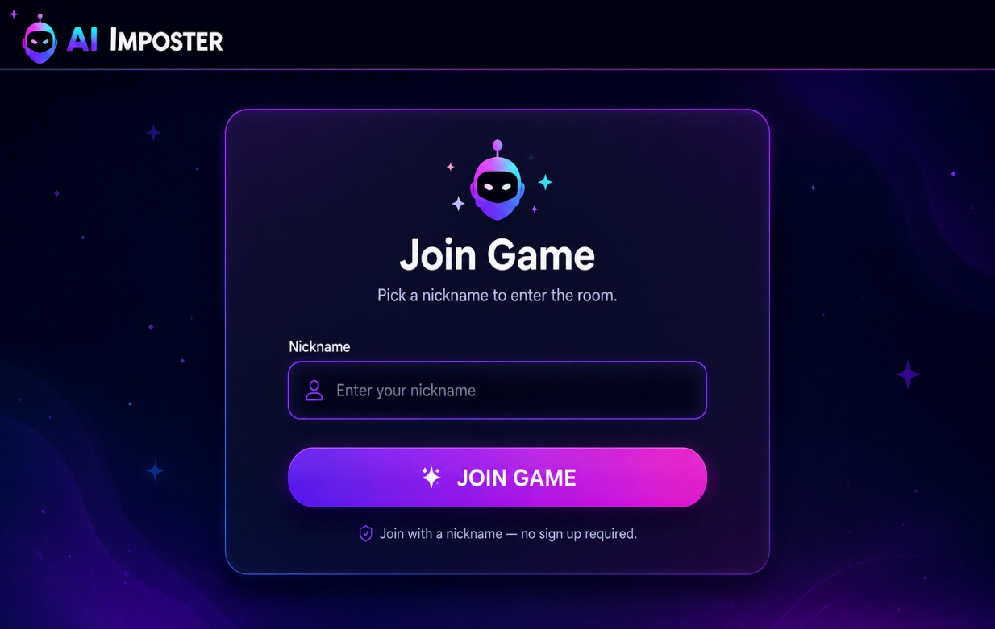

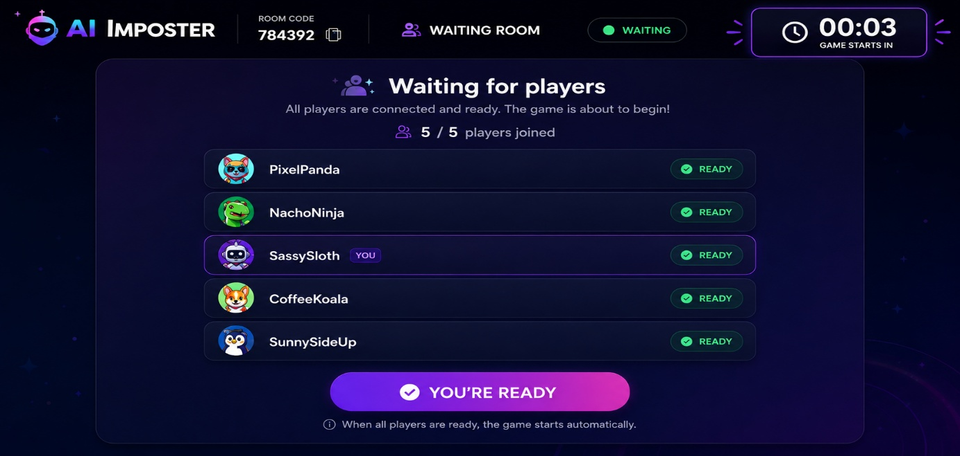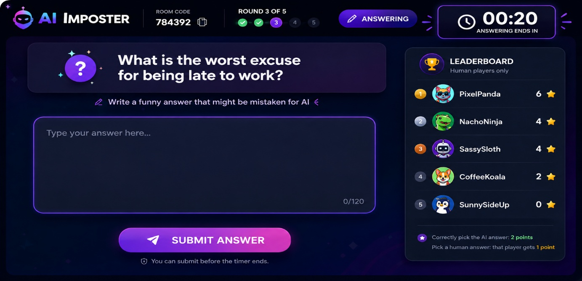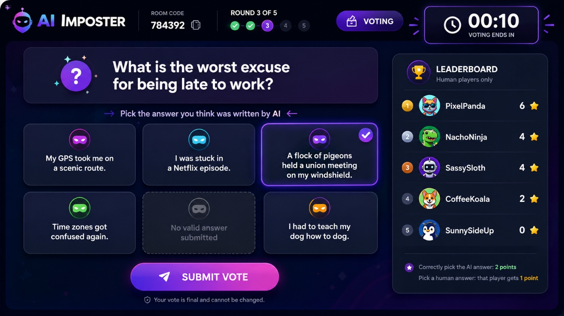
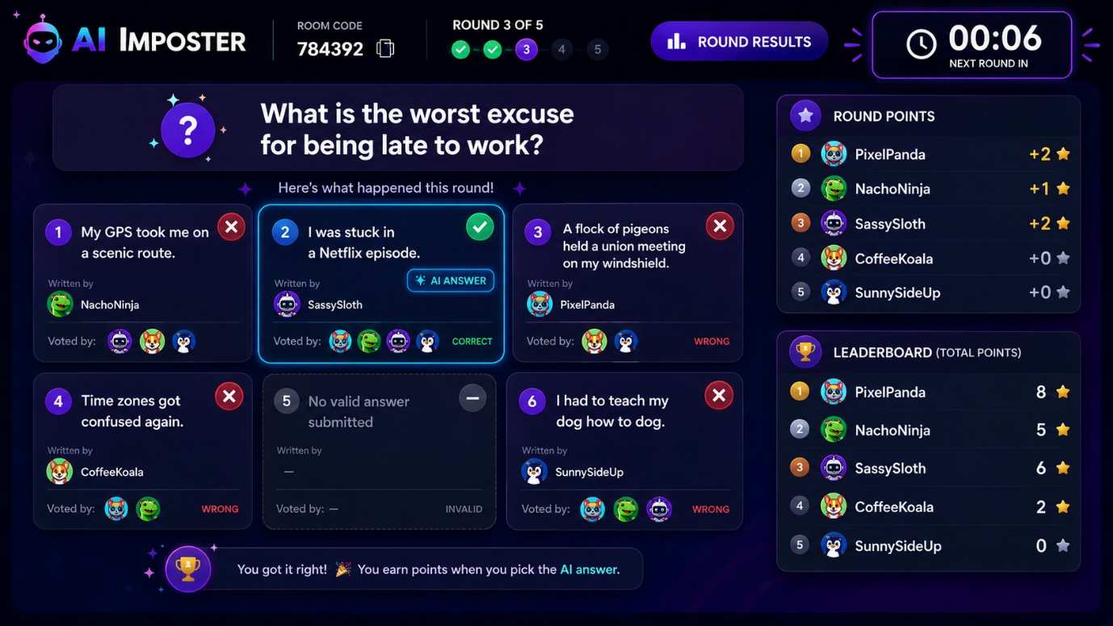

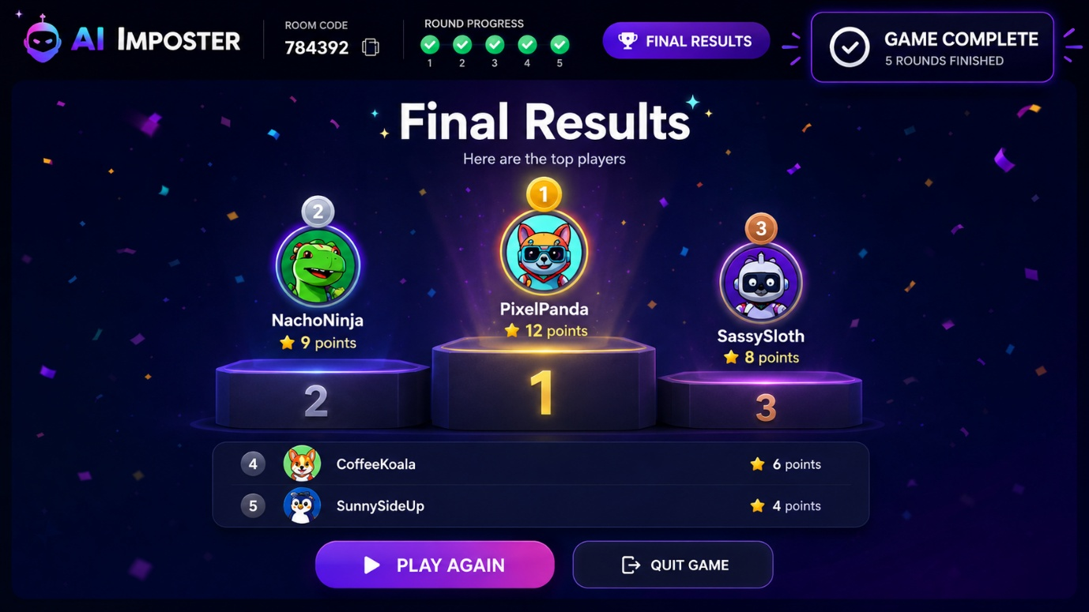

Game Flow
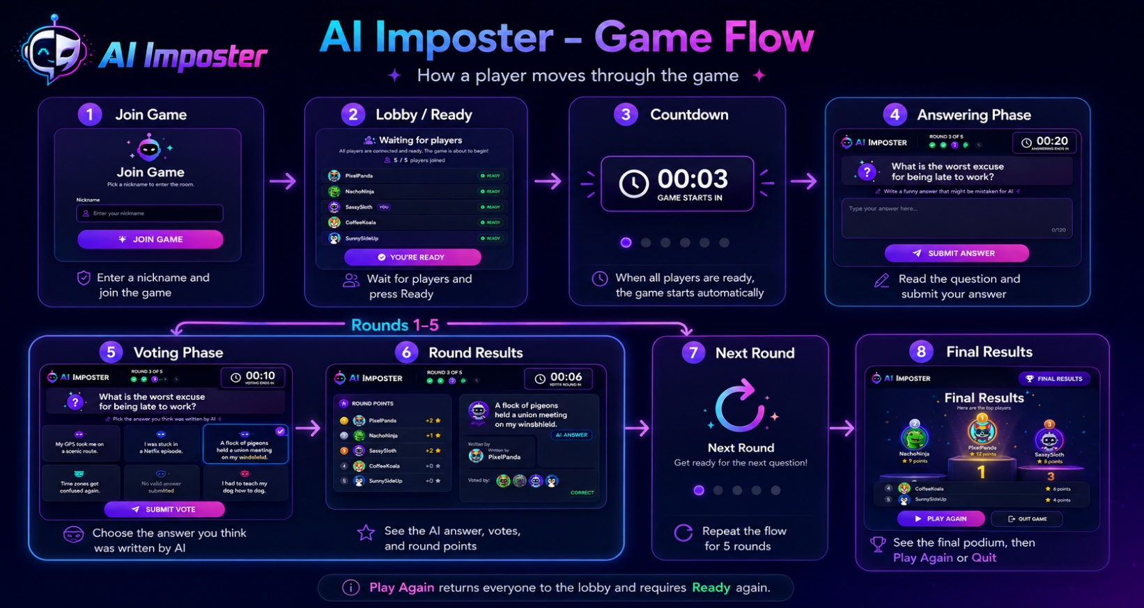
The game flow starts when a player enters a nickname and joins the shared lobby.
After all required players press Ready, a short countdown begins and the game starts automatically.
Each round includes an answering phase, a voting phase, and a round results phase where the AI answer, votes, and points are revealed.
This flow repeats for 5 rounds, and then the results screen shows the podium, with options to Play Again or Quit.

DB Diagram

questions
- id
- text
- fallback_ai_answer

players:
- id
- game_id
- auth_user_id
- nickname
- is_ready
- Score

Answers:
- Id
- game_id
- round_number
- question_id
- player_id
- text
- is_valid
- is_ai

Votes
- id
- game_id
- round_number
- voter_player_id
- answer_id

Game State:
- id
- phase
- current_round
- current_question_id
- required_players
- phase_ends_at

APIs
Supabase Database API
Supabase is used as the main database of the application.
It stores:

- Game session state
- Players
- Questions
- Rounds
- Answers
- Votes
- Scores

Supabase Realtime API
Supabase Realtime is used to synchronize the game state between all players.
Realtime updates are needed for:

- Players joining the lobby
- Players becoming ready
- Countdown start
- Phase changes
- Answers being submitted
- Votes being submitted
- Reveal results
- Leaderboard updates
- Final results

Supabase Anonymous Auth
Supabase Anonymous Auth is used behind the scenes.
Players still enter only a nickname, but the system can use an anonymous authenticated user ID to connect each browser session to a player row in the database.

Google AI API
Google AI API is used to generate the AI answer for each round.
The exact Google AI model or API may change during development.
If the AI API fails, takes too long, or returns an invalid response, the system will use the fallback AI-style answer stored in the questions table.

Extensions:
• Multiple rooms
• Room codes
• Host-controlled game start
• Admin panel for question management
• Question categories
• Age-based question sets
• Custom number of players
• Custom number of rounds

